Press Release
Recognition Evening for Youth in the Haut-Saint-Laurent
Rural Youth Gala 2015

Huntingdon, vendredi le 29 mai 2015 - For the sixth consecutive year, the involvement of youth implicated in the community of the Haut-Saint was celebrated at the Rural Youth Recognition Gala 2015. The event took place on Thursday, May 21st, with more than 200 people in attendance at Grove Hall in Huntingdon.
With the theme of "The Oscars", the audience had the chance to attend this spectacular recognition evening and were treated to many artistic performances from our youth; such as speedstacking, Irish dance choreography, singing, etc.
One could easily see the pride and sense of self-fulfillment in these young faces, who were accompanied by their families and friends. Nearly forty youth were nominated in various categories: Volunteer or Civic Involvement, Educational or Social Perseverance, Cultural Action and Healthy Lifestyle. The entire community was invited to nominate young people aged between 6 and 24 years old involved in their community.
During the evening, many dignitaries from different backgrounds took the floor to stress the importance of youth involvement in the community, but also to emphasize the importance and encourage them to persevere.
The winners of the various categories are:
Educational or Social Perseverance for Young People who have persevered throughout the school year, or that motivated another to persevere in academics or on a social level:
- 1st place – Eric Gour
- 2nd place – Johannie Emond
- 3rd place – Delphine Vranderick
- Coup de cœur du jury – Miguel Emond-Leduc
- Coup de cœur du jury – Jamy Lee Poole

Healthy habits for a young person who has conducted concrete actions to improve the quality of their eating habits, or young people who have made special efforts in physical activity by adopting an active lifestyle:
- 1st place : Christina-Michelle Buermans & Olyvia Faille
- 2nd place : Alexandra Tucker
Volunteering or Civic Engagement, young people who have rendered services to their community through their voluntary involvement in activities in the territory of Haut-Saint-Laurent or by their initiative for a promising project:
- 1st place – Kym Van Veen
- 2nd place – Sophie Patenaude, Callan Foster, Dayna Maither, Kaitlyn Courchesne, Kassandra Rancourt, Sara Jacobsen (L’équipe du Student Leadership Executive de CVR High School)
- 3rd place – Jade Mainville
- Coup de cœur du jury – Mackenzie & Jazzmin Ednie

Cultural Action, young people who have shown initiative to create a cultural project during the school year, or those who influenced other young people in their initiative
- 1st place – Wilbert Sweet & Roxanne Boursassa
- 2nd place - Andrea Soesbergen
There were 3 grand winners of the year in each of the categories.
1st Grand Winner : Lisa Richer
Determined to improve her situation, she persevered despite many social and physical challenges to become a positive role model who takes the initiative for projects and classroom services.

2nd Grand Winner : Samuel Larocque

Always volunteering his time when needed, Samuel is a role model to the youth around him by allowing young Scouts to experience great adventures.

3e Grand Winner : Jonathan Schinck-Pilon

He is involved in a new sporting challenge with faces it with perseverance and determination. He never gives up , works hard and always has a positive attitude in addition to supporting his group.

This year the award for Most Contribution to Youth in the Haut-Saint-Laurent was awarded to Nathalie Collin, director of Maison des Jeunes Huntingdon. Well known in the community, Ms. Collin's always involved in many projects; holiday camps, artistic workshops, Arts Street Festivals health promotion and prevention for young people by encouraging them to develop healthy lifestyles. Nathalie has developed many partnerships with other community organizations, schools and municipalities, etc. Professionally, her biggest achievement is offering a safe, healthy and learning environment where young people feel comfortable and listened to.

The organizing committee thanks all the people who attended this year’s Gala and the partners that helped make it and hopes to welcomes even more young people next year!

- 30 –

Sources

Lianne Finnie Geneviève St-Jacques Thériault
Intervenante Jeunesse Organisatrice communautaire
Maison des Jeunes de Huntingdon CSSS Haut-Saint-Laurent
4 rue Lorne, Suite 102, J0S 1H0 10, rue King, Huntingdon, J0S 1H0
(450) 322-6140, poste 105 (450) 829-2321, poste 1335
intervenantejeunesse@mdjh.ca genevieve.stjtheriault.cssshsl16@ssss.gouv.qc.ca

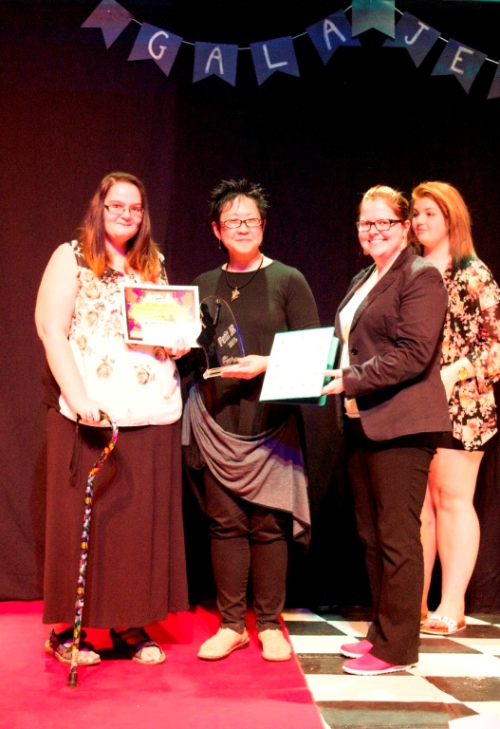
In the photo : Lise Richer, 1st place Winner overall, received her award from her teacher, Johanna cardinal, Julie Grondin, representative of Depute Anne Quach and Vanessa Duhème, 2014 grand winner.

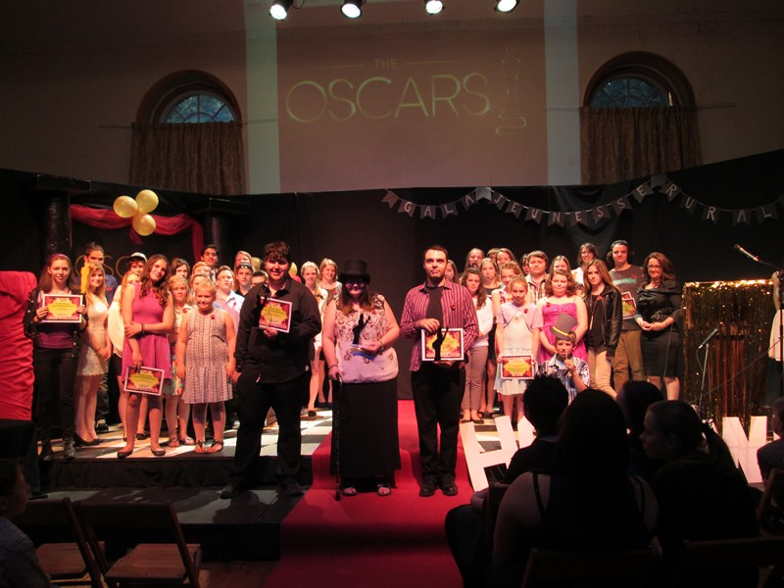
In the photo: The three grand winners, Johathan Schinck-Pilon, Lisa Richer et Samuel Laroque
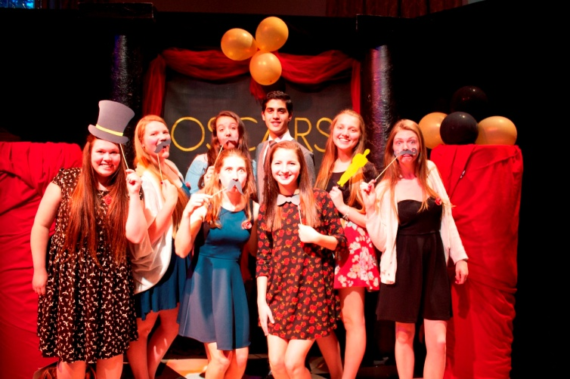
In the photo: A group of students from Châteaugay Valley Regional High School, implicated in healthy lifestyles and volunteerism.

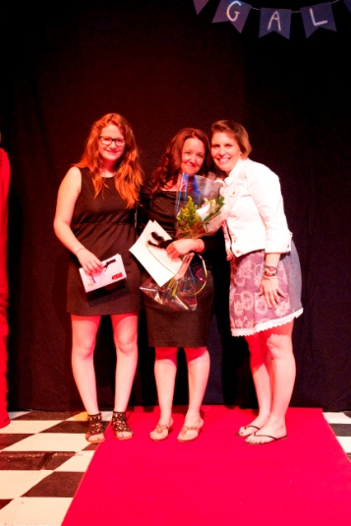
In the photos: Nathalie Collin, Most Contribution to Youth in the Haut-Saint-Laurent 2015, awarded by Jessica Taillefer, member of the Administrative Council of Maison des Jeunes and Lori Bélair, Arthur Pigeon High School.

